**Module 3: IBM Python Assignment**

|  |  |
| --- | --- |
| Assignment Date | 19 September 2022 |
| Student Name | Aishwarya.B |
| Student Roll Number | 311019104005 |
| Maximum Marks | 4 Marks |

**1.** Consider a list (list = []). You can perform the following commands:

insert i.e.: Insert integer at position.

print: Print the list.

remove e: Delete the first occurrence of integer.

append e: Insert integer at the end of the list.

sort: Sort the list.

pop: Pop the last element from the list.

reverse: Reverse the list.

Initialize your list and read in the value of followed by lines of commands where each command will be of the types listed above. Iterate through each command in order and perform the corresponding operation on your list.

**Solution:**

**N = 4**  
**append 1**  
**append 2**  
**insert 3 1**  
**print**

* **append 1:**Append **1** to the list, ***arr*** = **[1]**.
* **append 2:**Append **2** to the list, ***arr***= **[1, 2]**.
* **insert 3 1:**Insert **3**at index **1,*arr*** =**[1, 3, 2]**.
* **print:**Print the array.

**Output:**

[1, 3, 2]

12

insert 0 5

insert 1 10

insert 0 6

print remove 6

append 9

append 1

sort print

pop reverse print

[6, 5, 10]

[1, 5, 9, 10]

[9, 5, 1]

if __name__ == '__main__':

N = int(input())

L=[];

for i in range(0,N):

cmd=input().split();

if cmd[0] == "insert":

L.insert(int(cmd[1]),int(cmd[2]))

elif cmd[0] == "append":

L.append(int(cmd[1]))

elif cmd[0] == "pop":

L.pop();

elif cmd[0] == "print":

print(L)

elif cmd[0] == "remove":

L.remove(int(cmd[1]))

elif cmd[0] == "sort":

L.sort();

else:

L.reverse();

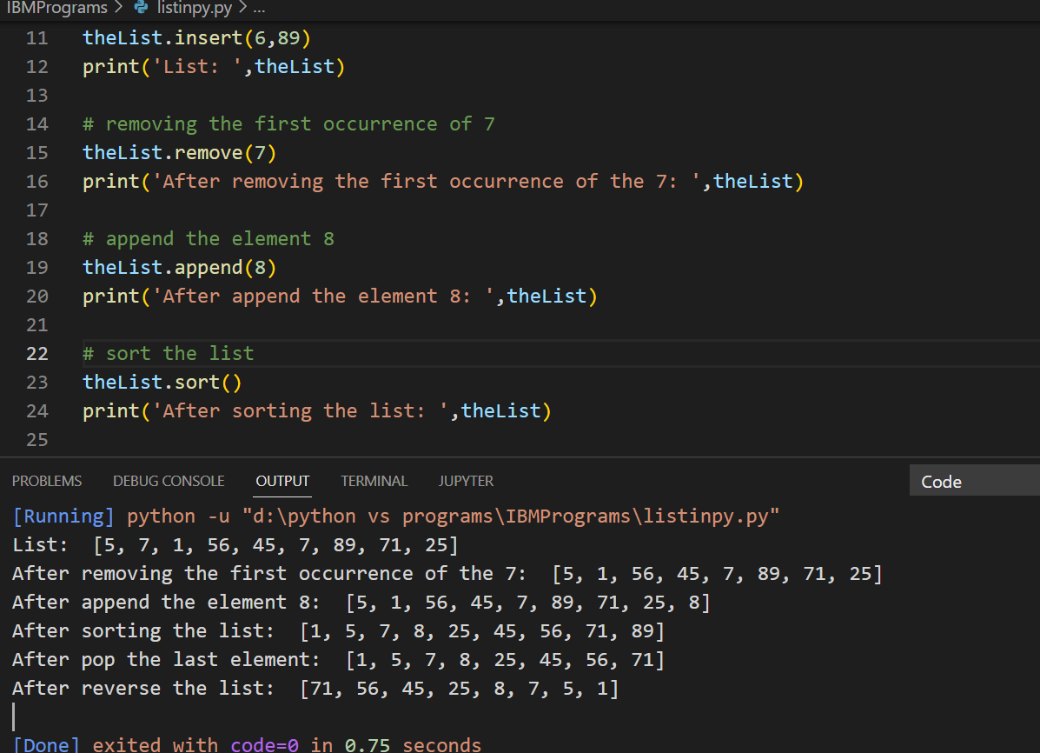

2. Write a Calculator program in Python?

**Solution:**

**# Program make a simple calculator**

**# This function adds two numbers**

**def add(x, y):**

**return x + y**

**# This function subtracts two numbers**

**def subtract(x, y):**

**return x - y**

**# This function multiplies two numbers**

**def multiply(x, y):**

**return x * y**

**# This function divides two numbers**

**def divide(x, y):**

**return x / y**

**print("Select operation.")**

**print("1.Add")**

**print("2.Subtract")**

**print("3.Multiply")**

**print("4.Divide")**

**while True:**

**# take input from the user**

**choice = input("Enter choice(1/2/3/4): ")**

**# check if choice is one of the four options**

**if choice in ('1', '2', '3', '4'):**

**num1 = float(input("Enter first number: "))**

**num2 = float(input("Enter second number: "))**

**if choice == '1':**

**print(num1, "+", num2, "=", add(num1, num2))**

**elif choice == '2':**

**print(num1, "-", num2, "=", subtract(num1, num2))**

**elif choice == '3':**

**print(num1, "*", num2, "=", multiply(num1, num2))**

**elif choice == '4':**

**print(num1, "/", num2, "=", divide(num1, num2))**

**# check if user wants another calculation**

**# break the while loop if answer is no**

**next_calculation = input("Let's do next calculation? (yes/no): ")**

**if next_calculation == "no":**

**break**

**else:**

**print("Invaid”)**

**Output**

Select operation.

1.Add

2.Subtract

3.Multiply

4.Divide

Enter choice(1/2/3/4): 3

Enter first number: 15

Enter second number: 14

15.0 * 14.0 = 210.0

Let's do next calculation? (yes/no): no

3. Write a program to concatenate, reverse and slice a string?

**Solution:**

#Reverse a string

def string_reverse(str1):

rstr1 = ''

index = len(str1)

while index > 0:

rstr1 += str1[ index - 1 ]

index = index - 1

return rstr1

print(string_reverse('1234abcd'))

sample output;

dcba4321

#concatenate a string

str1="python is"

str2="programing language"

print ("String 1:",str1)

print ("String 2:",str2)

str=str1+str2

print("Concatenated two different strings:",str)

sample output

String 1: python is

String 2: programing language

Concatenated two different strings: python is programing language

#slice a string

# Python program to demonstrate

# string slicing

# String slicing

String = 'ASTRING'

# Using slice constructor

s1 = slice(3)

s2 = slice(1, 5, 2)

s3 = slice(-1, -12, -2)

print(& quot

String slicing & quot

)

print(String[s1])

print(String[s2])

print(String[s3])

sample output;

String slicing

AST

SR

Gast

4. Why is Python a popular programming language?

**Solution**

The syntax in Python when compared to C++ or Java, **allows programmers to do coding in fewer steps**. Bigger organizations use it widely because of its multiple programming paradigms. Python has automatic memory management and dynamic features with a comprehensive and large standard library

Nearly a year after Python first topped Tiobe's index of programming language popularity, **the language continues to score high with develoeper**

5. What are the other Frameworks that can be used with python?

**Solution:**

* Bottle
* Flask
* Django
* Web2py
* AIOHTTP
* CherryPy
* Dash
* Falcon
* Growler
* UvLoop
* Pyramid
* Sanic
* CubicWeb
* TurboGears
* Hug
* MorePath

6. Full form of WSGI?

**Solution:**

The **Web Server Gateway Interface** (WSGI, pronounced whiskey or WIZ-ghee) is a simple calling convention for web servers to forward requests to web applications or frameworks written in the Python programming language

WSGI servers are designed **to handle many requests concurrently**. Frameworks are not made to process thousands of requests and determine how to best route them from the server. WSGI speeds up Python web application development because you only need to know basic things about WSGI.